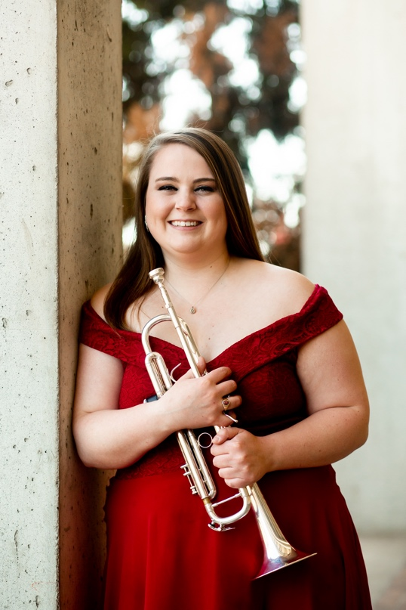
About the Teacher
Ms. Bartleman is a native of Des Moines, Iowa and entering her first year of teaching at Roosevelt High School. Prior to this role, she worked as a substitute teacher with the Special School Districts of Saint Louis. During her graduate studies at Southern Illinois University, Ms. Bartleman was a graduate teaching assistant for the Athletic Bands, including the Marching Salukis and SIU Pep Band. An accomplished musician, she has performed in a wide variety of ensembles, including wind ensemble, orchestra, jazz band, musicals, and chamber music. She resides in Saint Louis with her significant other and her two cats, Felix and Ella.
- Bachelor of Arts – Luther College, Music (2021)
- Master of Music – Southern Illinois University Carbondale, Trumpet Performance and Pedagogy (2023)
- Master of Education – University of Missouri Saint Louis, K-12 Instrumental Music Education (anticipated 2026)
Contact Information
Name: Ms. Rachel Bartleman
Email: Rachel.Bartleman@slps.org
Phone Number: (314) 776 – 6040
Room: 111

About the Course
Course Description
Understanding Music is a comprehensive course designed to introduce students to the fundamental concepts, styles, and elements of music. Students will explore the basics of music theory, including rhythm, melody, harmony, and form. They will also examine the role of music in society, the development of different musical genres, and the contributions of significant composers and musicians throughout history.
Required Materials
- Charged School Computer
Ms. Bartleman will not have extra computers for students to borrow.
- Notes Worksheets (Provided)
- Pencil/Highlighters
Grading
Points Breakdown
- Class notes & Listening Logs: 5 Points Daily
- Homework Assignments: 10 – 15 Points Each
- Unit Quizzes: 10 Points each
- Projects: 25 Points Each (50 Points Total)
- Midterm
- Final

Grading Scale
- A: 100 – 90
- B: 89 – 80
- C: 79 – 70
- D: 69 – 60
- F: 59 and below

Class Expectations
- Be respectful, responsible, courteous, and kind
- No inappropriate language
- No talking during instruction
- No food, drink, or chewing gum
- No cell phones or personal technology (headphones, personal laptops)
- Do not touch Smart Board or extra supplies without permission
- No hoods up (must be able to see ears)
- No vandalism (drawing on the walls, ripping down decorations)
- Do not open window blinds
- Do not touch other people’s belongings
- Clean up your own mess
- If a student borrows something from the teacher, they must give something as collateral

Class Procedures
- Students must enter the classroom before the bell rings. Once the bell rings, the classroom door will be locked, and students must have a valid hall pass to enter
- Daily agenda will be posted to the Smart Board for students to review as they enter the classroom.
- The students will have 2 minutes to put away distractions, get out writing utensils and be ready for instruction
- When the teacher stands in front of the class, all students are to stop side conversations and wait for instructions
- During class, all students are to actively participate and be engaged in what is happening.
- If a student needs to leave during class, they need to have a valid hall pass. See student handbook for further details.
- All students are to remain in their seats throughout the entire class period. No students are to line up at the door.
Class Notes
- Every day students must take written notes in class. Students are to complete notes on the provided note worksheets. These worksheets are not to leave the classroom for any reason.
- These worksheets will be checked every week and graded out of 3 points
- A student who has a verified absence will be exempt from notes for date of absence and will be encouraged to review materials on Teams.
- A student who has an unverified absence will be given a 0 for that day.
- A student who enrolled late due to schedule changes, they will be exempt from notes up until the date of their enrollment listed on SIS
- Students who sleeps during class or refuses to participate in class will receive a 0 for the day and a contact home will be made.

Listening Logs
- In addition to class notes, students will be completing Listening Logs. These listening logs include the following information:
  - Title (The name of song or piece)
  - Composer (who wrote it)
  - Performer (who performed it)
  - Style (Genre of music)
  - What do you hear? (Three adjectives)
  - Rating 1-5 and Why? (1 = Nope, not for me, 3 = Neutral, I don’t mind it, 5 = Love it!)
- These listening logs are done in class on their notes worksheet. We typically do these together as a class.
- If a student has a verified absence, they will be exempt from notes for date of absence. They will be encouraged to review materials on their own.
- If a student enrolled late due to schedule changes, they will be exempt from notes up until the date of their enrollment listed on SIS
- Student who sleeps during class or refuses to participate in class will receive a 0 for the day and a contact home will be made.
Unit Quizzes
- At the end of every unit, students will be given a 10 question, multiple choice quiz
- These are NOT open note quizzes. This is designed to assess what they know
- Students will be given the entire class period to complete these quizzes and makeup any notes they may have missed during the unit
- If a student is absent (verified) from the class or enrolled in the class late due to schedule changes, they will receive special permission from Ms. Bartleman to make up that quiz. Special arrangements will need to be scheduled so the student can complete the quiz.

Projects
- Students will be assigned 2 projects during the semester (1 Midterm, 1 Final)
- Ms. Bartleman will provide a detailed handout on the expectations of each project.
- Due dates for those projects will be posted on Teams and SIS. Students will be reminded of due dates as it comes closer

Unit dates
Subject to change
Unit 5: 1920s, 30s, & 40s (January 6th –February 3rd) 10 Classes
Unit 6: 1950s, 60s, & 70s (February 5th – March 5th) 10 Classes
Unit 7: 1980s & 90s (March 10th – April 11th) 10 Classes
Unit 8: 2000s, 2010s, & 2020s (April 14th – May 9th) 10 Classes
Review for Final: May 12th & May 14th
Final Exam: To be Determine

By signing this form, both the student & parent/guardian acknowledge that they have read the syllabus in-depth and understand the expectations and policies for this course.

Parent/Guardian Signature: __________________________________________________

Student Signature: _________________________________________________________

